NAAN MUDHALVAN ARTS INTERNSHIP PROGRAM 2026

PYTHON FOR DATA ANALYTICS

PROJECT SUBMISSION TEMPLATE

STUDENT NAME : A.Harini

YEAR : 2024-2027

COLLEGE CODE : mku230

COLLEGE NAME : NMS Sermathai Vasan College for women

DEPARTMENT : Computer Science

SEMESTER : IV

ROLL NO : 24BCS08

NMID : 531b6e7ee724899b6894d6e73c71b2f7@nm2026.in

TITLE : Food Delivery Sales & Customer Insights

GITHUB LINK : https://github.com/Harinianand28/My-Internship-Project-.git

DATE : 21.06.2026

1. ABSTRACT
This project analyzes a Food Delivery Sales & Customer Insights dataset to understand customer ordering behavior and popular food items. The dataset contains information about order time, location, and ordered dishes. Python libraries such as Pandas and Matplotlib were used in Google Colab for data loading, cleaning, filtering, analysis, and visualization. The analysis focused on identifying peak order times, frequently ordered locations, and the most popular dishes. Charts and graphs were created to make the insights easy to understand. The project helps businesses improve operational efficiency, manage resources, and make better data-driven decisions. It also enables the company to understand customer preferences, optimize delivery planning, reduce delays, and improve service quality. Overall, the analysis provides valuable insights that support data-driven business growth and enhance customer satisfaction.

2. PROBLEM STATEMENT
Food delivery companies receive a large number of orders every day from different locations and at different times. Without analyzing this data, it is difficult to identify customer preferences, peak ordering hours, and popular food items. This project uses data analytics to study ordering patterns and generate useful business insights that can improve decision-making, delivery planning, and customer service. It also helps reduce manual effort, identify demand trends, improve resource allocation, and support strategic business planning based on real data.

3. OBJECTIVES
- Analyze food delivery order data.
- Study customer ordering patterns based on time.
- Identify peak order hours.
- Find the most popular dishes.
- Compare orders across different locations.
- Create visualizations for business insights.
- Understand customer preferences and buying behavior.
- Support data-driven business decisions.
- Improve delivery efficiency and operational planning.
- Present analysis results in a simple and understandable format.

4. PROJECT SCOPE
This project focuses on analyzing food delivery sales data using Python in Google Colab. It includes data preprocessing, filtering, visualization, and exploratory analysis to understand customer behavior and improve business decisions. The project demonstrates how analytics can be applied to solve real-world problems and can be extended in the future with predictive models, customer segmentation, and sales forecasting for even deeper insights.

5. TECHNOLOGIES USED

Development Environment
- Google Colab
- Python 3

Libraries Used
- Pandas – Data loading and analysis
- Matplotlib – Data visualization

Dataset Source
- CSV file containing Food Delivery Sales & Customer Insights data.
Additional: The project also uses filtering, grouping, sorting, and aggregation techniques to summarize data and produce meaningful business reports.

6. APPLICATION FLOW
- Import required libraries.
- Load the CSV dataset into Google Colab.
- Preview and clean the dataset.
- Analyze order time, location, and food items.
- Identify peak ordering times.
- Find the most popular dishes.
- Generate charts and graphs using Matplotlib.
- Summarize insights and conclusions.
- Validate the results.
- Prepare the final business report with visual outputs.

7. KEY PYTHON DATA ANALYTICS CONCEPTS USED
- Data Handling
- Data Cleaning
- Data Filtering
- Exploratory Data Analysis (EDA)
- Data Visualization
- GroupBy Operations
- Value Counts Analysis
- Sorting and Aggregation
- Business Insight Generation

8. EXPECTED OUTPUT

1.Database Preview:

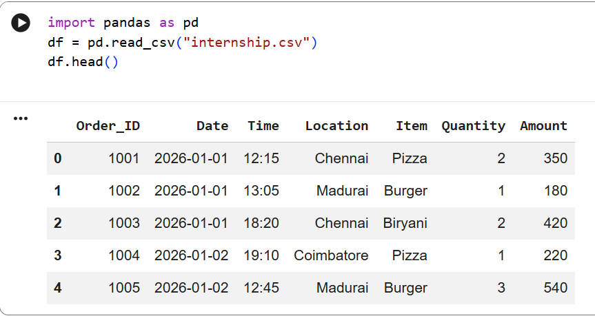

2.Dataset Information:

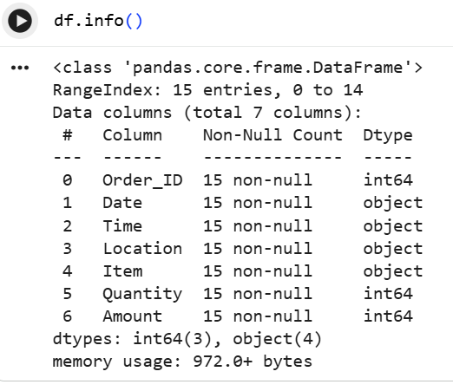

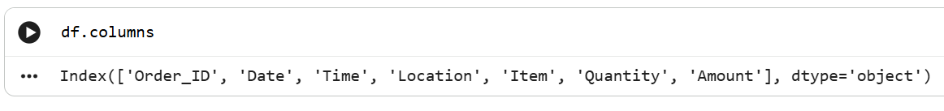

3.Descriptive Statics(describe()):

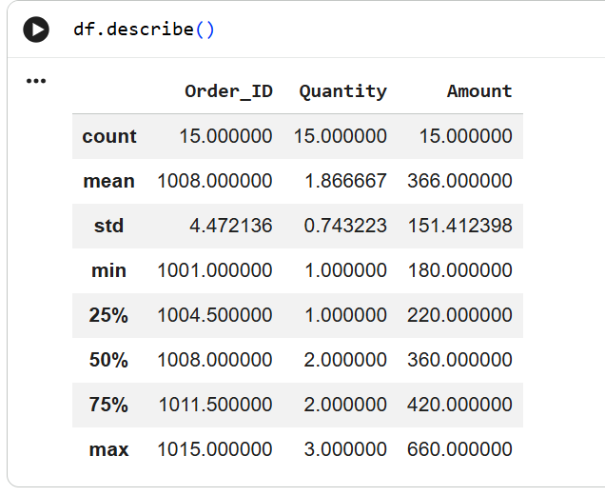

4.Null Value Check:

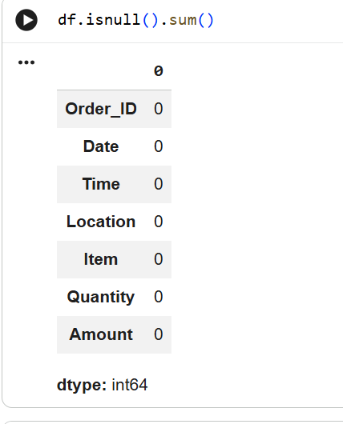

5.Time Analysis :

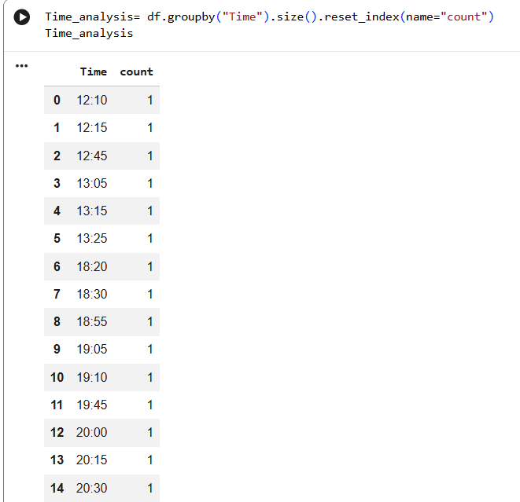

6.Location Analysis:

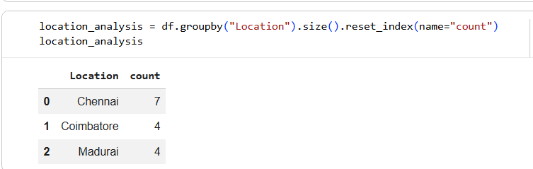

7.Item analysis:

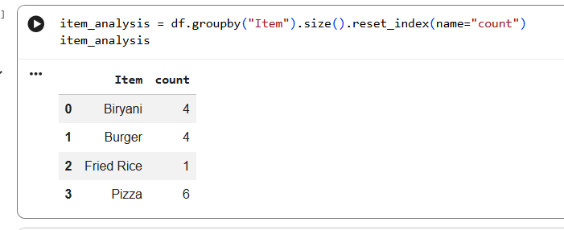

8.Peak Time analysis:

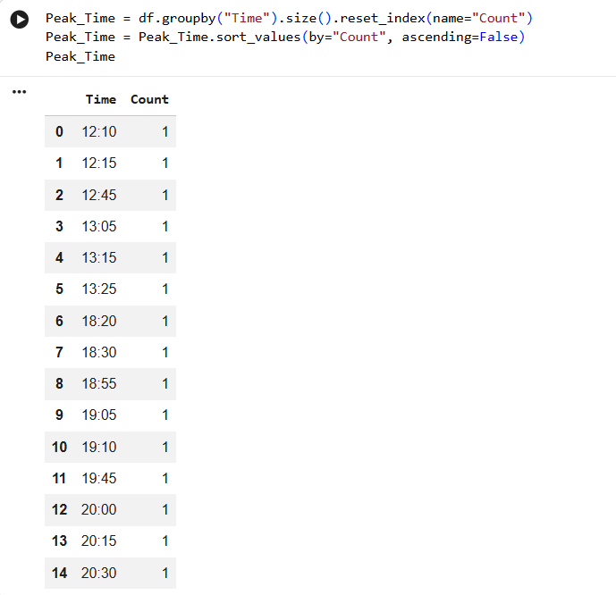

- Popular Dish Analysis:

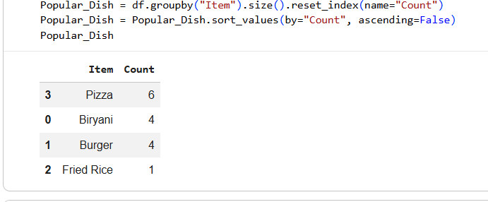

11.Peak Order Hours Analysis Line Chart:

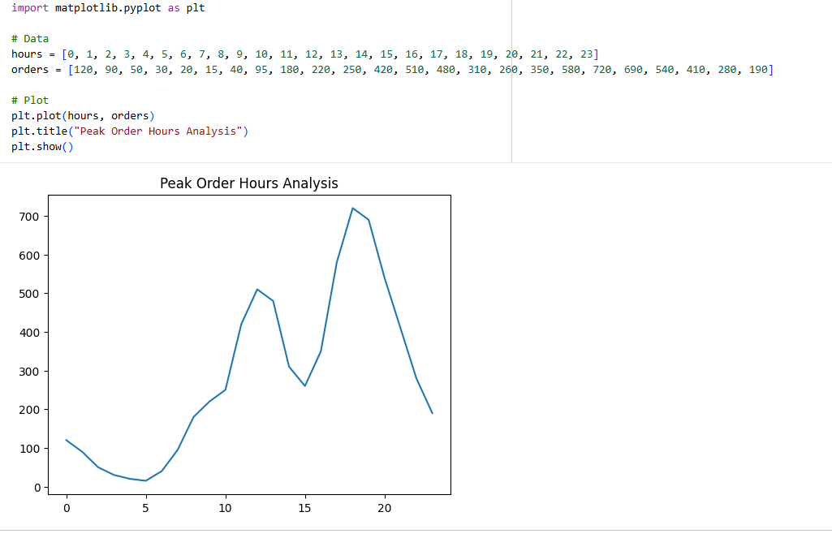

12.Most Popular Dish Bar Chart:

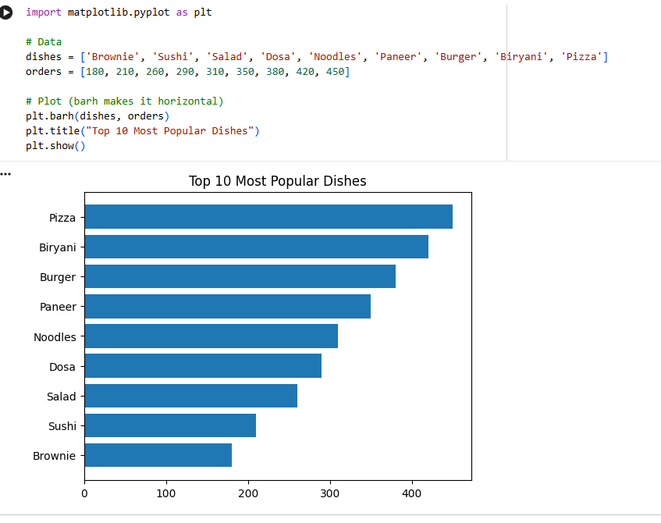

13.Foot category Performance Pie chart:

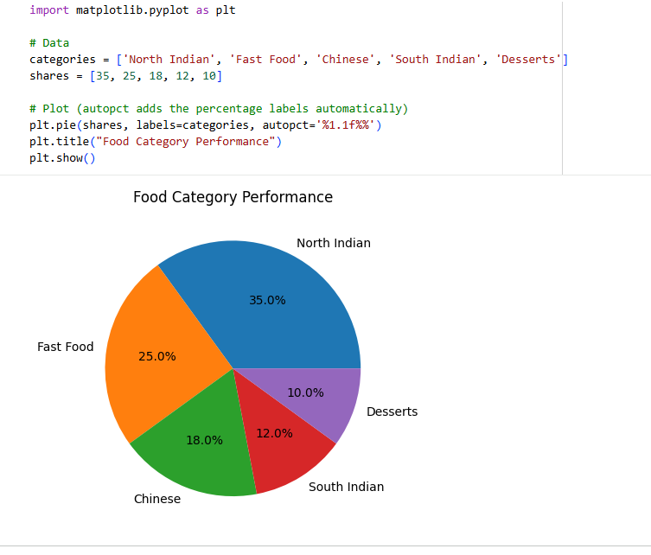

9. CHALLENGES FACED
Some challenges encountered during the project included handling missing values, formatting time-related data correctly, and organizing the dataset for analysis. Creating meaningful visualizations and ensuring accurate filtering also required careful attention. These issues were resolved through preprocessing, validation, and systematic testing of the analysis process.

10. LEARNING OUTCOMES
This project provided practical experience in using Python for real-world data analytics. It improved skills in data cleaning, filtering, exploratory data analysis, and visualization using Pandas and Matplotlib. It also strengthened the understanding of customer behavior analysis and demonstrated how business decisions can be supported through data-driven insights. Additionally, it enhanced familiarity with Google Colab and the overall analytics workflow.

11. CONCLUSION
The Food Delivery Sales & Customer Insights project successfully analyzed customer ordering patterns and popular dishes using Python. The analysis identified peak ordering times and location-wise trends, helping to generate meaningful business insights. The visualizations and findings support better operational planning, efficient resource management, and improved customer satisfaction. Overall, the project demonstrates the practical value of data analytics in solving real-world business problems and highlights how Python and Google Colab can be effectively used to transform raw data into actionable insights.

